Chemistry

Unit 2

Area of Study 8 Test Answers

Rates of chemical reactions

Section 1: Multiple choice 30% (10 marks)

Question 1

B Endothermic processes are those that require energy. To melt chocolate (or any substance) heat energy is needed.

The condensation of liquid water to ice releases heat, so is exothermic. The reaction of methane (CH4) with oxygen is a combustion reaction releasing heat energy, so is exothermic. The combustion of paper, like all combustion reactions, releases heat energy, so is exothermic.

Question 2

C The higher the number of molecules exceeding the activation energy, the greater the reaction rate.

Reaction rate is directly proportional to concentration of reactants, that is, as concentration of reactants increases reaction rate increases. The smaller the particle size, the greater the surface area of reactants, and so the greater the reaction rate. As temperature increases, the rate of both endothermic and exothermic reactions increases.

Question 3

A High pressure of water vapour will increase the frequency of collisions between CH4 and H2O molecules and so increase the rate of reaction to produce hydrogen faster.

Low pressure of methane gas will reduce the frequency of collisions between CH4 and H2O molecules. Because carbon monoxide and hydrogen are products, their pressures will not have a direct effect on the rate of formation of hydrogen.

Question 4

D The reaction occurs readily at room temperature, indicating little energy is needed for reaction to occur; thus it has a small activation energy. As well, the release of sparks and flames indicates release of energy so it is an exothermic reaction.

Question 5

A For reaction to occur, molecules need to collide with an orientation that favours breaking of bonds in reactant molecules and formation of new bonds in the products, as well as colliding with enough energy to break bonds in reactant molecules.

End of section 1

Section 2: Short answer 70% (24 marks)

\* indicates 1 mark

Question 6

a As the reaction proceeds the concentration of acid decreases\*, thus the frequency of collisions between the reactants decreases and so the rate of reaction decreases\*. The reduced rate of reaction means less carbon dioxide is produced in each (20 second) time increment\*.

(3 marks)

b The volume of carbon dioxide gas produced in fixed time increments (say 20 seconds) could be measured\*; or the pH could be measured at fixed time increments (say 20 seconds)\*. (Accept any appropriate method.) (1 mark)

Question 7

a Green additions to graph and new labels (3 marks)

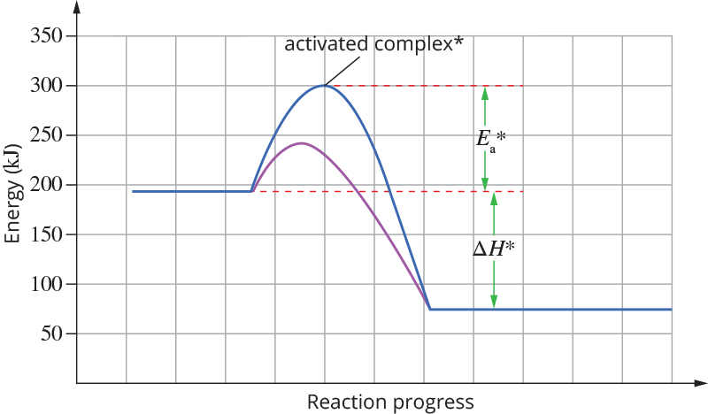

b i ∆H = −135 kJ ± 5 kJ\*

ii Ea = 240 kJ ± 5 kJ\*

(2 marks)

c Purple curve on graph: Ea less than uncatalysed pathway\*, ∆H same as in uncatalysed pathway\*

(2 marks)

d The catalyst will increase the rate of reaction\*. It increases the rate of reaction by providing a reaction pathway with a lower activation energy\*, which means the proportion of collisions with sufficient energy to react will be higher than in the uncatalysed pathway\*. (3 marks)

Question 9

a The rate of production of hydrogen chloride gas will be faster at high pressures of hydrogen and chlorine gases\*. This is because at high pressure the frequency of collisions between the H2 and Cl2 molecules is increased\*, and so increase the number of successful collisions\*. (3 marks)

b High temperature will increase the rate of production of hydrogen chloride gas\*. At higher temperature, the frequency of collisions is increased, which leads to higher rate of reaction\*. More significantly, at higher temperature a higher proportion of molecules will collide with energy above the activation energy, so giving a higher rate of reaction\*. The diagram shows that at high temperature there is a higher proportion of molecules with energy above the activation energy\*.

Marks for diagram: axes appropriately labelled\*; high and low temperature curves shown\*; Ea shown\*

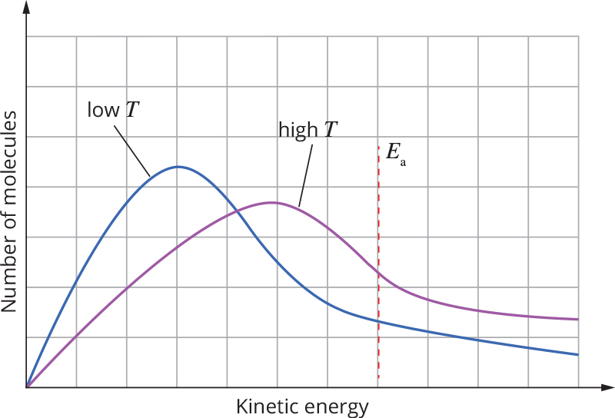

(7 marks)

End of answers